Epi INfotm WEb Analytics & visualization (EWAV) quick start guide

Version 1.0

05/01/2014

VERSION HISTORY

|  |  |  |  |
| --- | --- | --- | --- |
| **Version #** | **Implemented**  **By** | **Revision**  **Date** | **Comments** |
| 1.0 | Kenyatta W. Stephens | 10/24/2013 | Version 1.0 of the document |
| 1.0 | Sachin Agnihotri | 02/21/2014 | Version 1.0 review and updates |
| 1.0 | Leslyn McNabb | 5/1/2014 | Version 1.0 review and updates |
|  |  |  |  |

TABLE OF CONTENTS

1 Introduction 4

1.1 Purpose 4

1.2 Audience 4

2 System Overview 5

2.1 EWAV Location 5

2.2 First-Time Users 5

3 EWAV Features 5

3.1 Welcome screen 5

3.2 Dashboard Overview 6

3.3 Gadget Menu 7

3.3.1 Gadgets 7

3.3.2 Charts 8

3.3.3 StatCalc Calculator 9

3.4 Defined Variables 9

3.5 Data Filter 10

4 Getting Started 10

4.1 Logging In 10

4.2 Setting the Data Source 11

4.3 Opening Saved Dashboards 12

# Introduction

## Purpose

Epi Info™ Web Analytics & Visualization is an open source project in the popular Epi Info™ suite of tools. The web product can be deployed as an internet or intranet application and will provide analytical and visualization capability for large public health datasets within an organization. The product will also provide a collection of relevant public health related tools that can be used by Epidemiologists or other public health professionals to analyze data.

The purpose of this document is to serve as a Quick Start Guide for the Epi InfoTM Web Analytics & Visualization system.

## Audience

The audience for this document includes public health practitioners who will be analyzing data sets via the web.

# System Overview

## EWAV Location

The EWAV system can be accessed at the following URL: <http://WEB_SERVER_NAME/ewav/ewav.aspx>

## First-Time Users

EWAV can be accessed by navigating to the application URL in the browser. The system is configured with a Super Administrator account. The Super Administrator should follow the steps of “Forgot password” to receive their login credentials to use the system for the first time. Super Administrators can create user accounts for their organization. Once the users are set up they will be able to login to the application.

# EWAV Features

## Welcome screen

1. After logging in to the system, the following EWAV welcome screen will appear:

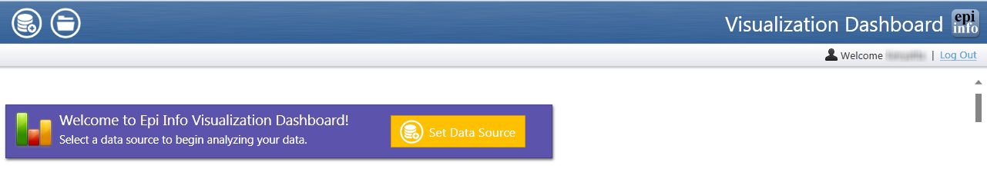

This screen allows you to either set a data source () for analyzing data or open a previously saved dashboard ().

1. 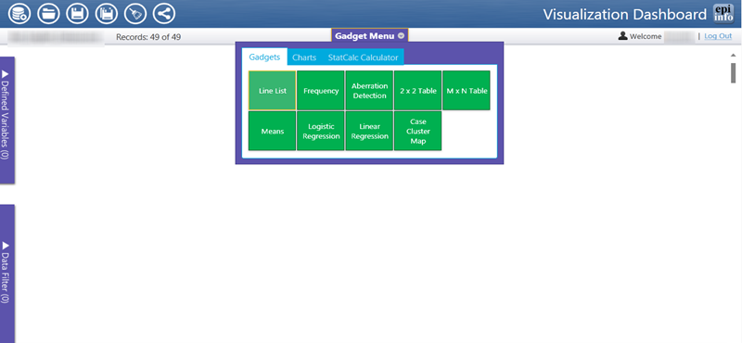The following screen will appear after the welcome screen and after the user has selected their data source and clicked on the Gadget Menu:

The name of your data set will appear on this screen along with the number of records contained in that data set.

## Dashboard Overview

The Menu strip on the top of the page has several icons, defined as:

 Set Data Source

 Open Dashboard

 Save Dashboard

 Save As

 Clear Dashboard

 Share Dashboard

## Gadget Menu

The Gadget Menu allows access to the Gadget menu, Charts, and the StatCalc Calculator available in EWAV.

### Gadgets

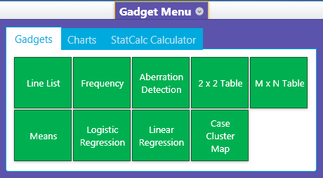

Some common analytical tools in EWAV include:

* Line list
* Frequency
* Aberration Detection (currently the EARS C1 algorithm)
* 2 x 2 Tables
* Custom Tables (MxN table)
* Means
* Logistic Regression
* Linear Regression
* Case Cluster Mapping

### Charts

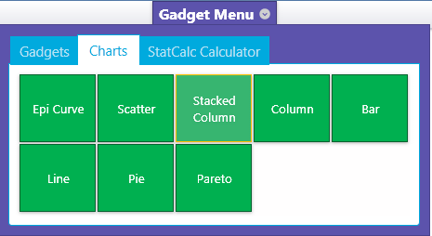

The charts available in EWAV include:

* Epi Curve
* Scatter
* Stacked Column
* Column
* Bar
* Line
* Pie
* Pareto

### StatCalc Calculator

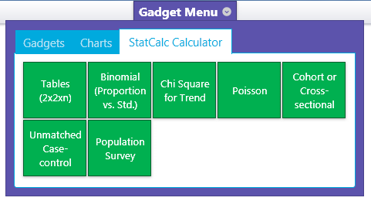

The tools available with the StatCalc Calculator include:

* 2x2 Analysis with Associated Statistics
* Binomial Probability
* Chi Square test
* Poisson Probability
* Sample Size & Power Calculation (Unmatched Cohort & Cross-Sectional Studies)
* Sample Size & Power Calculation (Unmatched Case-Control Studies)
* Sample Size & Power Calculation (Population Surveys & Descriptive Studies)

## Defined Variables

You are able to create new variables from the existing variables in your data set. The number in parentheses indicates the number of variables created.

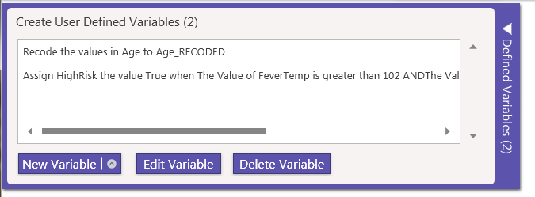

## Data Filter

You are able to create filters based on the existing variables in your data set. The number in parentheses indicates the number of filters created and applied.

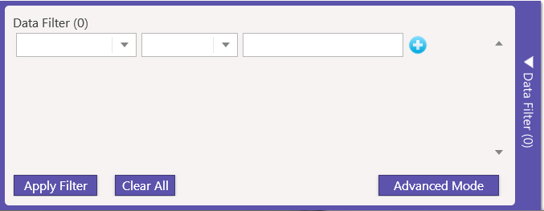

# Getting Started

## Logging In

If you are logging in to the system when the product has been deployed as an Intranet application using windows authentication, you will not be prompted to enter Log In information as your user ID (email address) will be automatically authenticated.

If you are logging in to EWAV when the system has been deployed as an internet application using Forms authentication, you will be prompted to enter a user name and password.

1. Enter your user ID.
2. Enter your password.

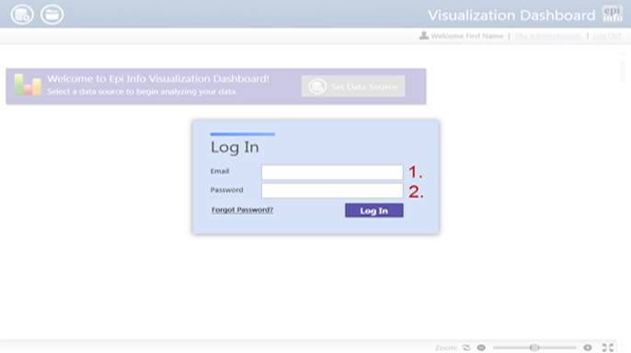

## Setting the Data Source

1. Set the Data Source for your Project.

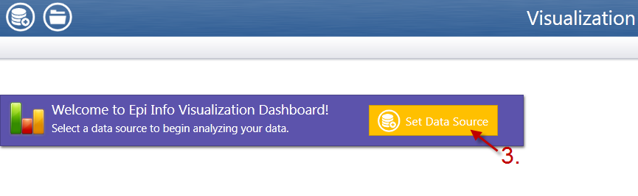

1. Click Set Data Source drop-down menu to select the data source you will be using for the project.

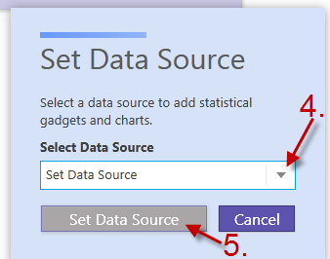

1. Click the Set Data Source button to retrieve the data source.
2. The Gadget Menu will appear.
3. The data source name is shown in the header.
4. The number of records in the data source is shown in the header as well.

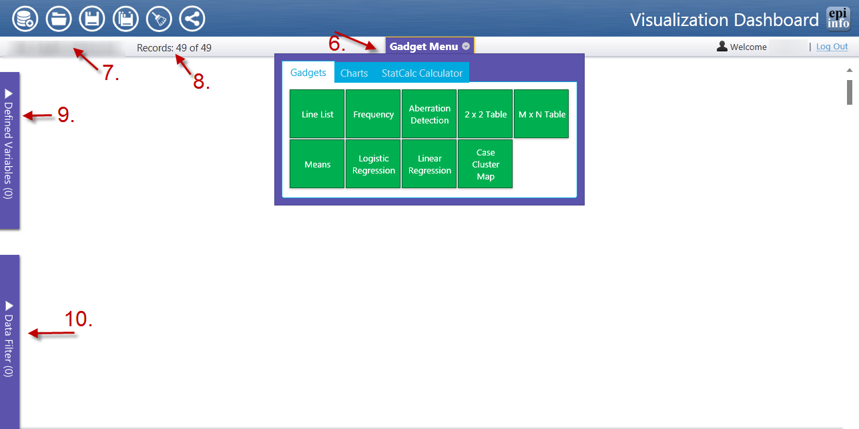Note:

New variables can be created in the data set using the Defined Variables tab (9).

Data filters can be created using the .Data Filter tab (10).

**Note: Users are able to save data queries and analytics created in the dashboard by clicking the Save Dashboard icon**.



## Opening Saved Dashboards

1. Open the saved dashboards created previously.

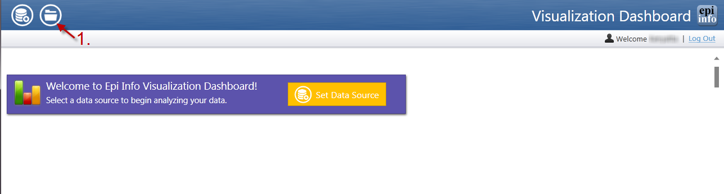

**NOTE: You will see a list of dashboards with saved output data.**

1. Click the Select Dashboard drop-down menu to open a saved dashboard.

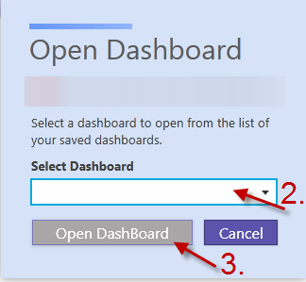

1. Click the Open Dashboard button. The saved analyses will appear on your screen.

**You are now able to continue with data analysis.**